**Full name : PHẠM MINH TUẤN MID-TERM TEST**

**Class :** K22MSC Subject: English 1(Listening + Reading + Writing)

Allotted time: 90 ms

**B. READING (30 points)**

**PART I: (10 points) – CIRCLE the best answer**

1. She __________ Vietnam several times.

A. visit B. is visiting C. has visited D. visited

2. During her childhood, her parents __________ in Paris.

A. live B. lived C. have lived D. were living

3. He _________ for the same company since he left school.

A. works B. has worked C. worked D. was working

4. She __________ the bank. Please call her back later.

A. has gone out B. has been to C. has been out D. has gone to

5. I have not seen him __________ three years.

A. for B. since C. from D. at

6. The fish is....................thing on the menu.

A. the best B. goodest C. gooder D. better

7. Though he earns.................much money as I do, he always says he runs short of money.

A. as twice B. twice as C. so twice D. twice so

8. Any employee …………..….shows great performance will be rewarded.

A. which B. who C. whom D. whose

9. Sales staff member …………....….English is fluent will have a chance to move abroad.

A. who B. which C. whom D. whose

10. We issue a membership card …………..…..can be used in many facilities.

A. which B. who C. whose D. whom

**PART II (5 POINTS) – CIRCLE the best answer**

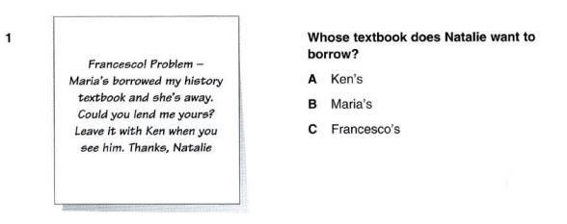

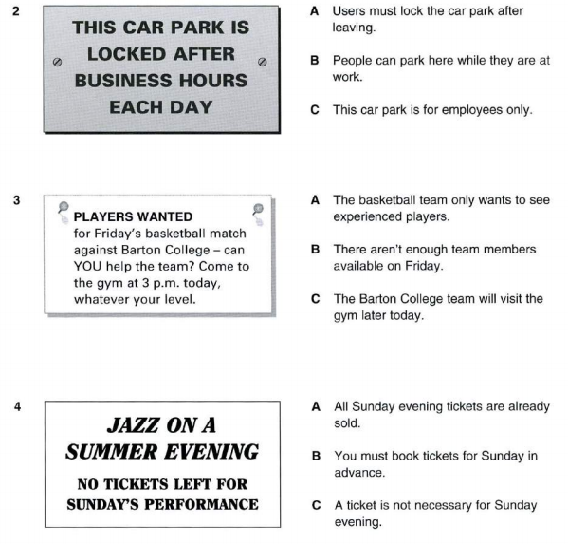

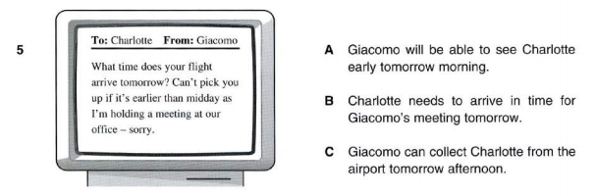

**PART III (5 points) – CIRCLE the best answer**

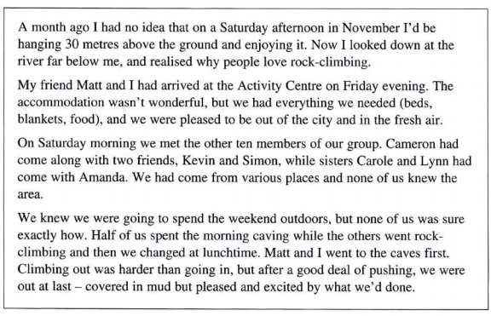

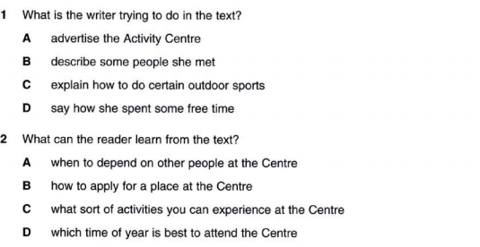

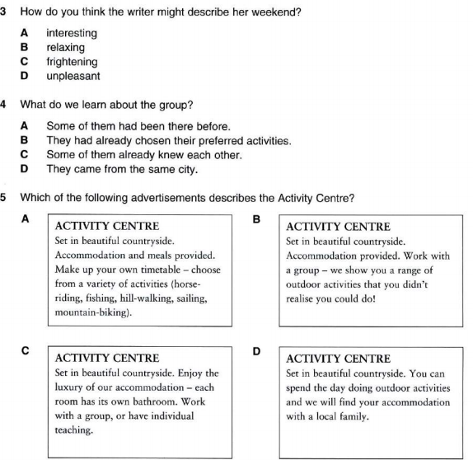

**PART IV- (10 points) Complete each blank of the reading text with ONE suitable word.**

**THE FIRST WOMAN SCIENTIST**

Hypatia was born in Alexandria, in Egypt, in 370 A.D. For many centuries she was (1) ……………… only woman scientist to have a place in the history books.

Hypatia’s father was director of Alexandria University, and he (2) ……………. sure his daughter had the best education available. This was unusual, as most women then had few (3) ………………. to study.

After studying in Athens and Rome, Hypatia returned to Alexandria (4) ……………. She began teaching mathematics. She soon became famous (5) …………… her knowledge of new ideas.

We have no copies of her books, (6)……………. we know that she wrote several important mathematical works. Hypatia was also interested in technology and (7)…………. several scientific tools to help with her work.

At the (8) ……………. many rulers were afraid of science, and (9) ………….. connected with it was in danger. One day in March 415, Hypatia (10) ……………. attacked in the street and killed.

1. A. one B. the C. a D. an

2. A. could B. made C. said D. put

3. A. classes B. customs C. opportunities D. teachers

4. A. where B. how C. there D. which

5. A. from B. by C. for D. in

6. A. because B. but C. or D. as

7. A. did B. experimented C. invented D. learnt

8. A. day B. period C. year D. time

9. A. anyone B. nobody C. all D. something

10. A. was B. had C. has D. is

**C. WRITING (30 points)**

**PART I (10 points)**

**Complete the second sentence so that it has a similar meaning to the first one**.

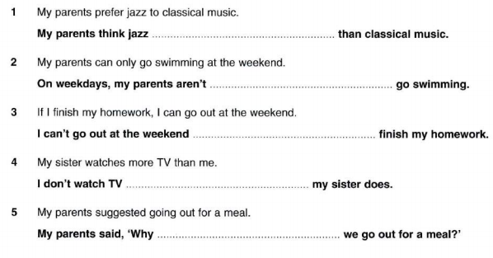

**------------------------------------------------**

**------------------------------------------------**

**------------------------------------------------**

**------------------------------------------------**

**-------------------------------------------------**

***is better***

***don’t***

***unless I***

***able to***

***as much as***

**PART II (20 POINTS)**

Write a paragraph of 100-120 words about the advantages OR disadvantages of shopping online. Use supporting ideas to develop your opinion.

*Nowadays, shopping online becomes a popular way in e-commerce websites and social networks. It’s essential for people because, after work, we must go home and don’t have much time for shopping. In my opinion, shopping online has lot of advantages over traditional markets or supermarkets.*

*The most obvious advantage is consumers will save much more time and money than the common shopping. Information on products can be found easily through a few clicks. On the other hand, we can choose to buy anything which a better price and warranty policy because a lot of sellers offer the same products. Lastly, before buying, buyers can refer to the feedback from previous customers to evaluate product quality.*

**---THE END --**